**Tableau Assignment- 2**

**1. Creating Advanced Charts:**

**○ Using the "Superstore" dataset, create a Bar-in-Bar chart that compares actual**

**sales to target sales for each category. Provide a screenshot of your**

**visualization.**

Ans:

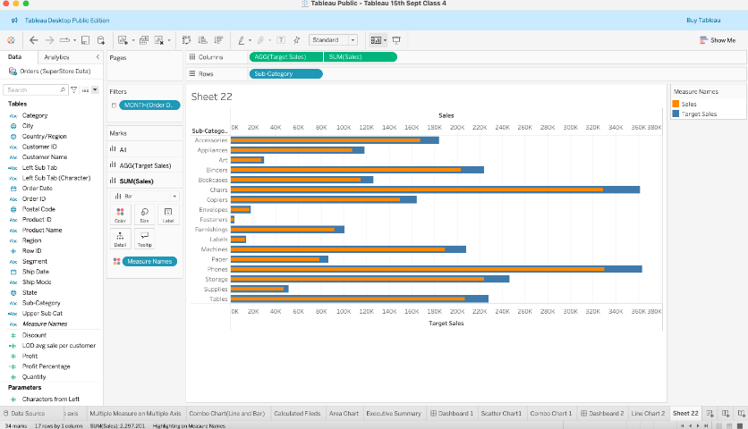

**2. Creating Bullet Charts:**

**○ Create a Bullet chart to show the performance of each region against the overall**

**sales target using the "Superstore" dataset. Provide a screenshot of your**

**visualization.**

Ans:

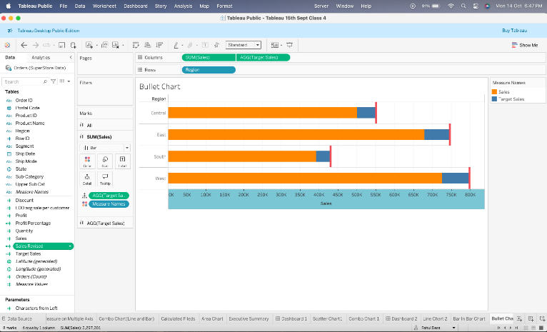

**3. Creating Histograms:**

**○ Create a Histogram to display the distribution of order quantities in the**

**"Superstore" dataset. Provide a screenshot of your visualization.**

**Ans:**

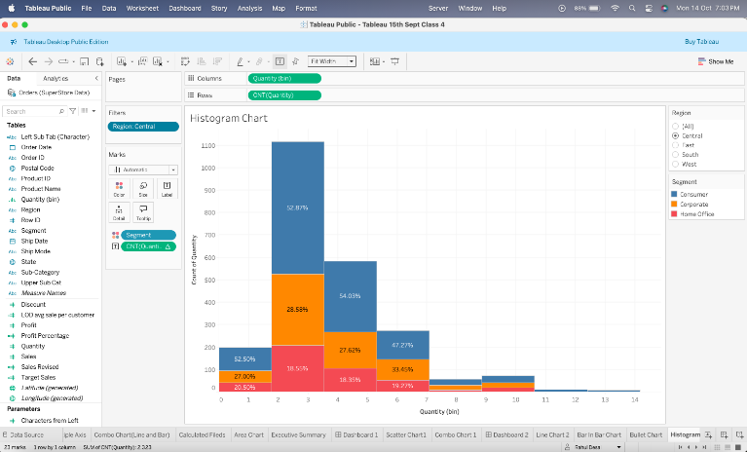

**4. Creating Box Plots:**

**○ Create a Box Plot to display the distribution of profits by region in the**

**"Superstore" dataset. Provide a screenshot of your visualization.**

**Ans:**

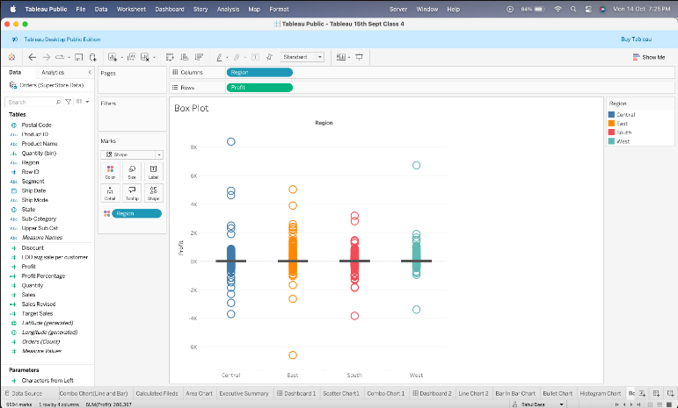

**5. Using Dual-Axis and Combined Charts:**

**○ Create a Combined Dual-Axis chart that shows sales as bars and profit as a line**

**over time using the "Superstore" dataset. Provide a screenshot of your**

**visualization.**

**Ans:**

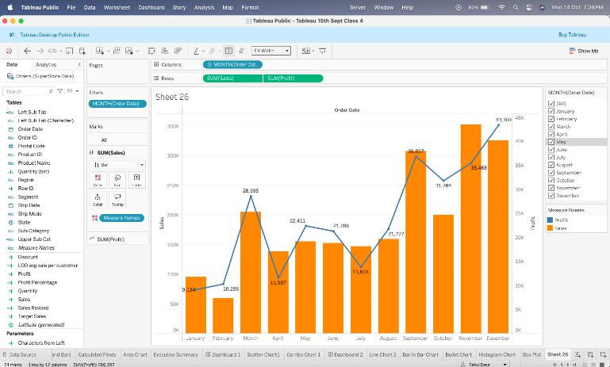

**6. Creating Calculated Fields:**

**○ Create a calculated field named "Sales to Profit Ratio" defined as**

**SUM([Sales]) / SUM([Profit]). Use this field to create a visualization that**

**shows this ratio by category. Provide a screenshot of your calculated field and**

**the resulting visualization.**

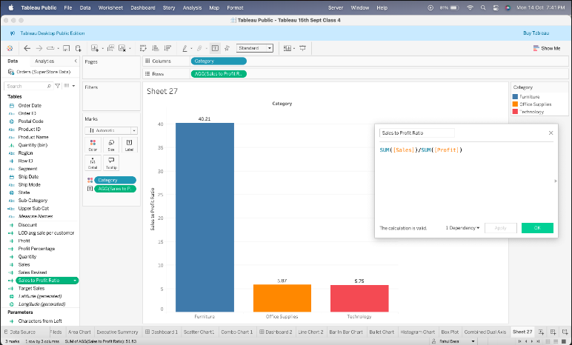

**7. Using Parameters:**

**○ Create a parameter that allows the user to choose between viewing total sales or**

**total profit in a bar chart for each category. Implement this parameter and provide**

**a screenshot of your parameter setup and the resulting visualization.**

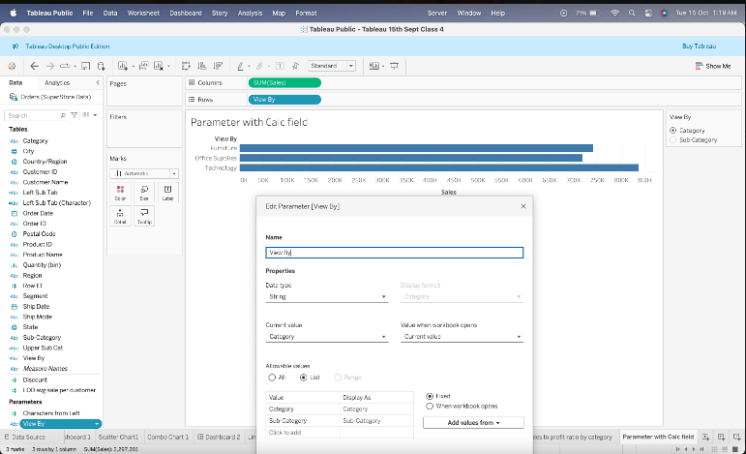

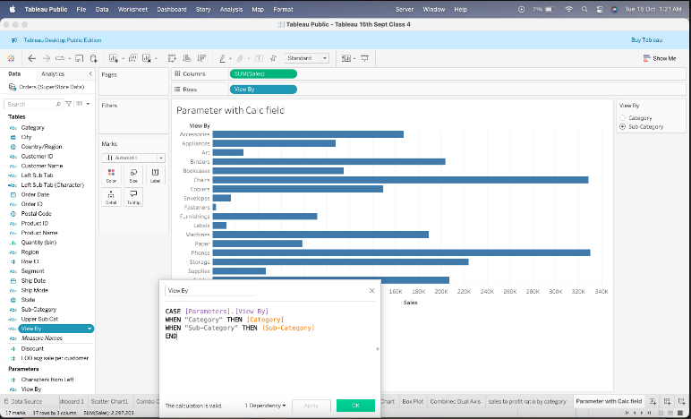

**8. Using Sets:**

**○ Create a set for the top 10 customers by sales in the "Superstore" dataset. Use**

**this set to create a visualization that highlights these top customers in a bar chart.**

**Provide a screenshot of your set setup and the resulting visualization.**

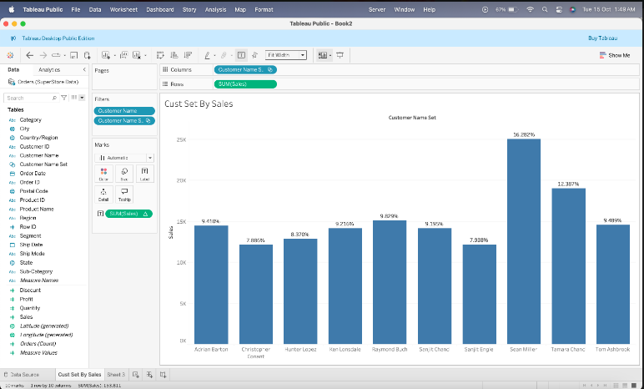

**9. Using Groups:**

**○ Group the sub-categories into technology, furniture, and office supplies**

**categories. Create a visualization to show the total sales for these groups.**

**Provide a screenshot of your group setup and the resulting visualization.**

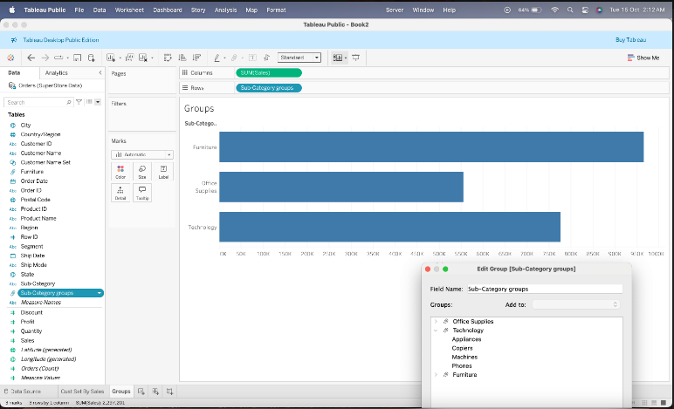

**10. Customizing Tooltips:**

**○ Customize the tooltips for a scatter plot that shows sales vs. profit by**

**sub-category in the "Superstore" dataset. Include additional information such as**

**the profit ratio and the number of orders. Provide a screenshot of your**

**customized tooltips and the resulting visualization.**

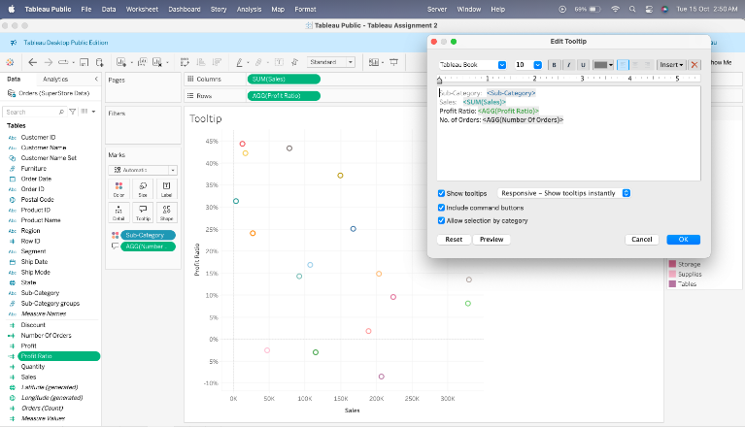

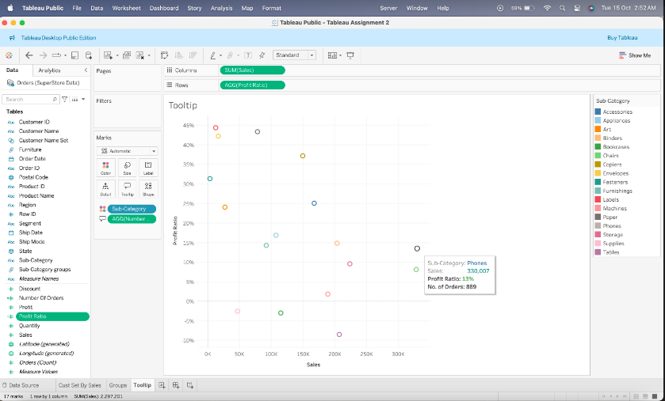

**11. Adding Annotations:**

**○ Add an annotation to a line chart that shows sales over time to highlight a**

**significant sales event (e.g., a spike in sales). Provide a screenshot of your**

**annotated visualization.**

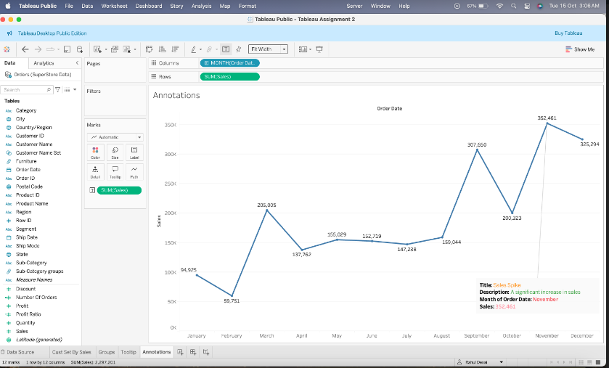

**12. Creating Interactive Dashboards:**

**○ Create an interactive dashboard that includes at least three different**

**visualizations from the previous sections. Add interactivity such as filters,**

**highlight actions, and parameter controls. Provide a screenshot of your**

**interactive dashboard.**

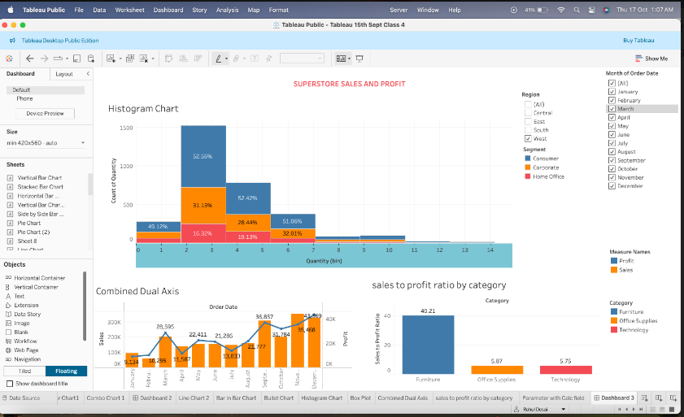

**13. Adding Filters to Dashboards:**

**○ Add filters to your dashboard from Question 12 that allow the user to filter by**

**region and date range. Provide a screenshot of your filters setup and the**

**resulting dashboard.**



**14. Designing for Different Devices:**

**○ Create a device-specific dashboard view optimized for tablets. Ensure that the**

**layout and interactivity are preserved. Provide a screenshot of your**

**tablet-optimized dashboard view.**

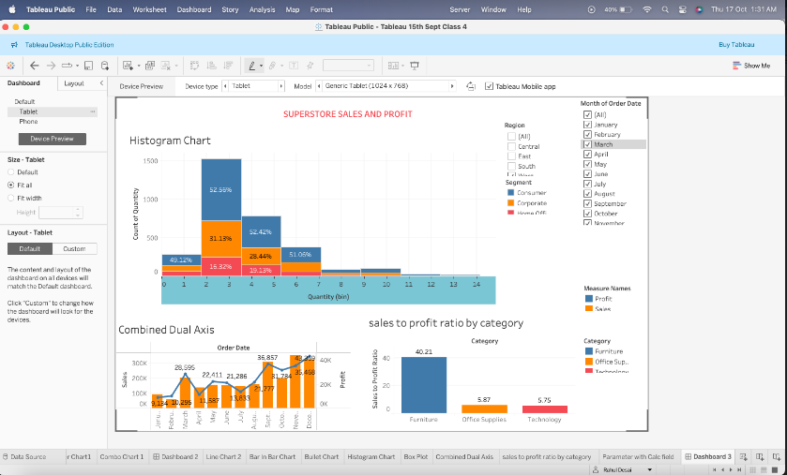

**15. Creating Stories:**

**○ Create a Tableau story that narrates the sales performance over time,**

**highlighting key insights using the visualizations created in previous questions.**

**Include at least three story points. Provide a screenshot of your story setup and**

**each story point.**

